PROJECT REPORT AI Loan Eligibility
Checker

A web-based application for loan estimates and financial insights

Student | Aaditya Vaijinath Shinde
Department | Artificial Intelligence – Data Science
Academic Year | 2026–2027
Project Type | Web Application / AI-assisted Financial  Tool

LIVE DEMO
https://ai-loan-eligibility-checker-tbo8.onrender.com
https://github.com/adityashinde123/AI-Loan-Eligiblity-Cheker

1. Abstract

AI Loan Eligibility Checker is a web-based application designed to help users explore an estimated loan eligibility outcome and understand selected financial indicators. The application brings together a loan eligibility checker, credit score analyzer, EMI calculator and financial tips page in a single interface. The backend is built with Python and Flask, while HTML, CSS and JavaScript provide the user interface. The project includes a loan model and a dataset, and can request general financial tips from the Anthropic Claude API. If the external AI service is unavailable, the application can display fallback educational tips. The application is deployed on Render and its source code is maintained in GitHub.

2. Introduction

Loan decisions can depend on several factors, including income, existing financial commitments and credit history. It can be difficult for a first-time borrower to understand how these factors relate to affordability. This project provides a simple web interface where users can explore an educational estimate, calculate an EMI, review a credit-score category and access general financial guidance.

3. Problem Statement

Users may find it difficult to estimate loan affordability, understand the significance of a
credit score, and calculate the monthly repayment amount before applying for a loan. A beginner-friendly digital tool is useful for bringing these basic calculations and explanations together in one place. The result must be treated as an educational estimate, not as a lender's final decision.

4. Objectives

- Provide an interface for checking an estimated loan eligibility outcome.
- Help users understand a credit score through a category, risk indication and general advice.
- Calculate monthly EMI, total payment and total interest from user-entered values.
- Offer general financial planning tips, using an AI service when available and fallback tips otherwise.
- Build a responsive web application using a Python backend and web technologies.
- Publish the source code on GitHub and deploy the application on Render.

5. System Flow / Architecture

The user interacts with the browser-based interface. The frontend sends requests to Flask routes. Flask validates input and calls the relevant application logic. The loan model handles eligibility prediction, the EMI route performs the repayment calculation, the credit-analysis route classifies the entered score, and the AI-tips service attempts to call Anthropic Claude before using fallback tips if needed.

USER
HTML / CSS / JavaScript Frontend
Flask Routes and Input Validation
Loan Model • EMI Calculation • Credit Analysis • AI Tips Service
JSON Response → Results shown in the browser

6.Tools and Technologies Used

Category | Technology / Tool | Purpose
Frontend | HTML5, CSS3, JavaScript | Pages, styling, user interaction and requests
Backend | Python, Flask | Routes, input processing and application logic
Eligibility logic | LoanEligibilityModel, loan dataset | Generate an estimated eligibility result
AI integration | Anthropic Claude API | Generate general financial tips when available
API communication | JSON, HTTP / Fetch requests | Exchange data between frontend and backend
Version control | GitHub | Store and manage source code
Deployment | Render, Gunicorn | Host and serve the web application
Development | VS Code / local Python environment | Write and test the application

7. Main Modules

Module | Description
Dashboard | Main landing page providing navigation to the application's features.
Loan Eligibility Checker | Accepts user-provided financial information, validates it and returns an estimated result from the loan model.
Credit Score Analyzer | Accepts a credit score from 300 to 900 and returns a score band, risk indication and general advice.
EMI Calculator | Calculates monthly EMI, total payment and total interest from loan amount, annual interest rate and tenure.
AI Financial Tips | Requests general tips from Anthropic Claude; if the service fails or credits are unavailable, returns fallback educational tips.
Health Endpoint | Provides a simple service-status response for deployment checks.

8. Development Process

- Organized the Flask application and supporting service modules.
- Created the web pages and static frontend assets.
- Implemented the loan prediction route and input validation.
- Implemented the EMI calculation and credit score analysis routes.
- Integrated the AI financial tips service with safe fallback handling.
- Prepared project dependencies and deployment configuration.
- Uploaded the source code and dataset to GitHub.
- Deployed the application on Render and reviewed the runtime logs to troubleshoot deployment and API issues.

9. Web Application Interface

Insert screenshots from the deployed application in the spaces below before submitting the report. Use actual screenshots of the working pages so that the documentation accurately represents the submitted project.
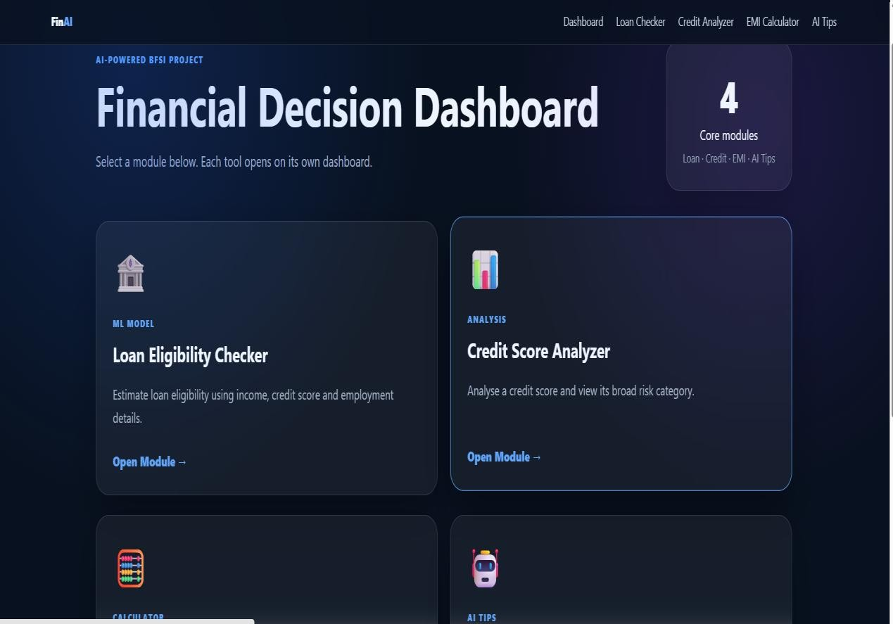

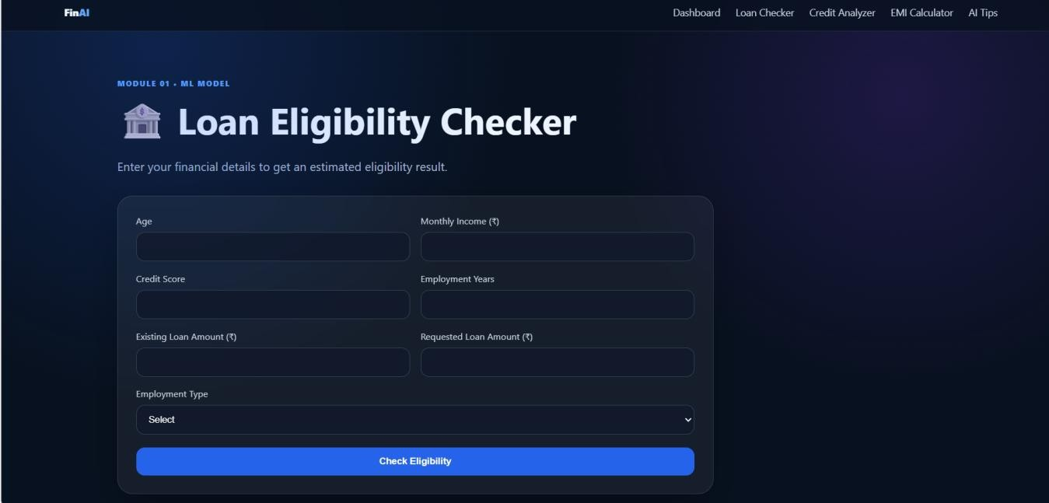

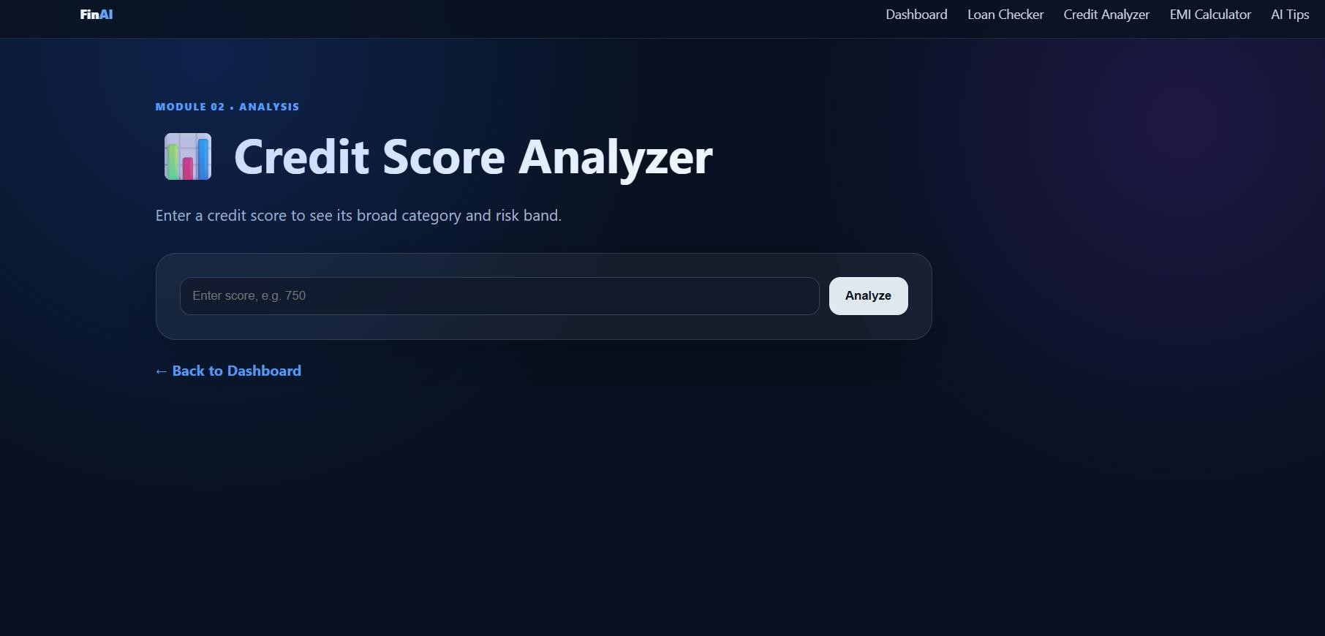

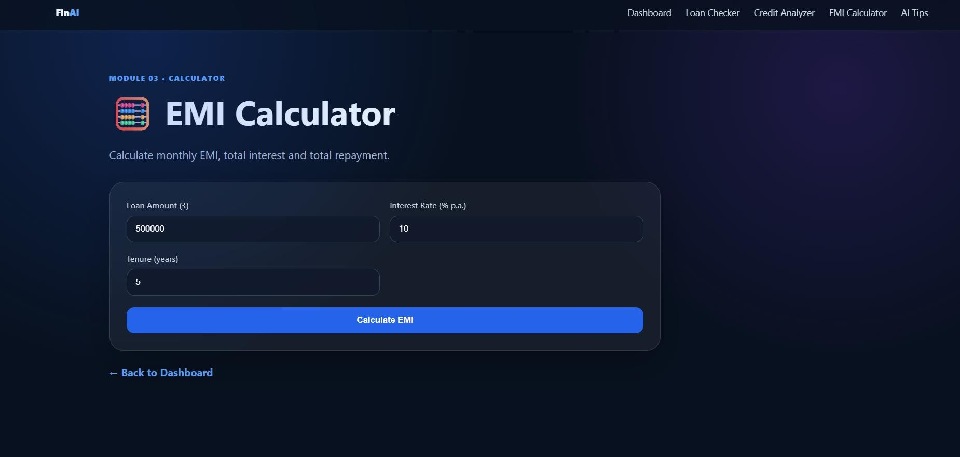

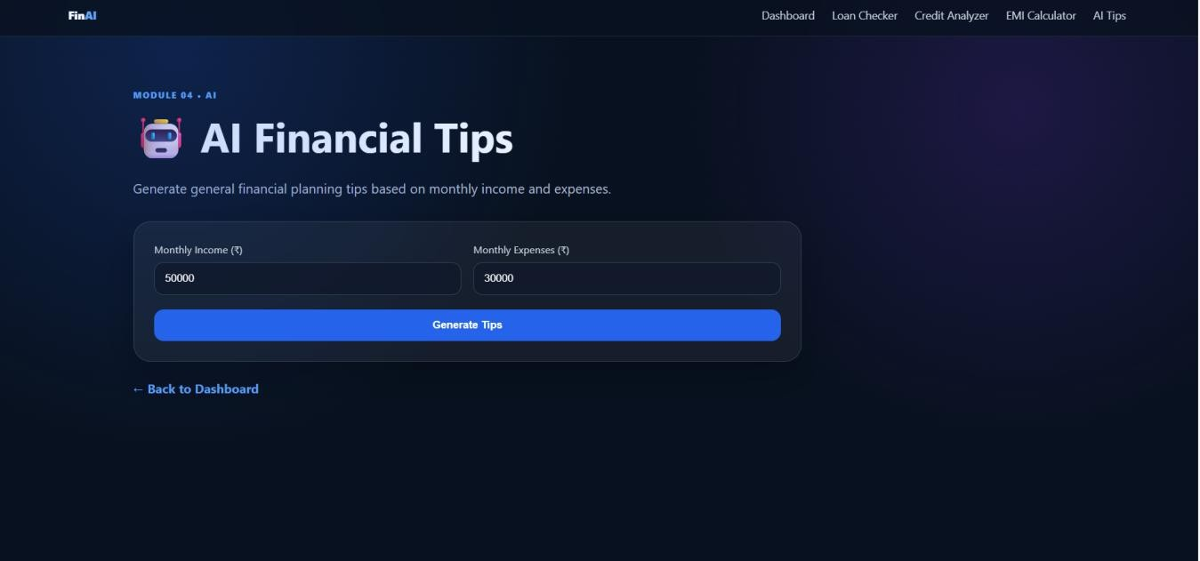

10. Testing

The following table lists important checks for the main application flows. Confirm each result against the deployed application before final submission and update the status if a test behaves differently.
Test Case | Expected Result | Status
Open dashboard | Dashboard loads successfully. | Verify
Open each module | The corresponding page loads. | Verify
Submit valid loan details | An eligibility estimate is returned. | Verify
Submit invalid loan details | Validation errors are returned clearly. | Verify
Calculate EMI with valid values | Monthly EMI, total payment and interest are displayed. | Verify
Enter a credit score from 300–900 | Score band, risk and general advice are returned. | Verify
Enter an invalid credit score | A validation message is returned. | Verify
Generate AI financial tips | Claude tips appear when API access is available; fallback tips appear otherwise. | Verify
Open deployed site | The Render-hosted site responds successfully. | Observed live

11. Results
The project is deployed as a web application and includes separate pages for loan eligibility, credit score analysis, EMI calculation and financial tips. The application uses Flask routes to process requests and return results to the frontend. During deployment troubleshooting, the AI tips feature was updated to provide fallback educational tips when the Anthropic API cannot be used, such as when the API credit balance is insufficient.

12. Limitations

- Loan eligibility output is an estimate and is not a guaranteed lending decision.
- The quality and availability of live AI-generated tips depend on Anthropic API access, billing and service availability.
- Fallback tips are rule-based educational messages and are not generated by the live AI service.
- The application should not be used as a substitute for professional financial advice or a lender's formal assessment.

13. Conclusion

AI Loan Eligibility Checker demonstrates how a Python Flask backend can be combined with a browser-based frontend to provide practical financial tools in one application. It brings together loan eligibility estimation, credit score analysis, EMI calculation and financial tips. The project also provided practical experience in API integration, input validation, version control, cloud deployment and error handling.

14. Future Scope

- Add user authentication and secure user profiles.
- Improve the loan prediction model through further validation and suitable training data.
- Add downloadable PDF reports for calculations and results.
- Improve accessibility and mobile responsiveness after usability testing.
- Add more detailed explanations of the factors affecting an eligibility estimate.
- Provide clearer user-facing indicators when live AI tips are replaced by demo tips.

15. Project Links

Resource | Link
Live Demo | https://ai-loan-eligibility-checkertbo8.onrender.com
GitHub Repository | https://github.com/adityashinde123/AI-Loan-Eligiblity-Cheker

16. References
- Python Documentation — https://docs.python.org/3/
- Flask Documentation — https://flask.palletsprojects.com/
- Anthropic API Documentation — https://docs.anthropic.com/
- Render Documentation — https://render.com/docs
- GitHub Documentation — https://docs.github.com/

